
Name Date
Maths Task
1. Making 1
(a) Join all the pairs of numbers that add together to equal 1
The first one is done for you.
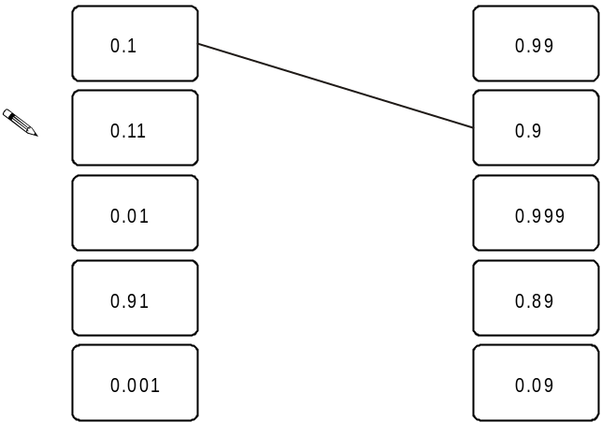
2 marks
(b) Now join all the pairs of numbers that multiply to equal 1
The first one is done for you.
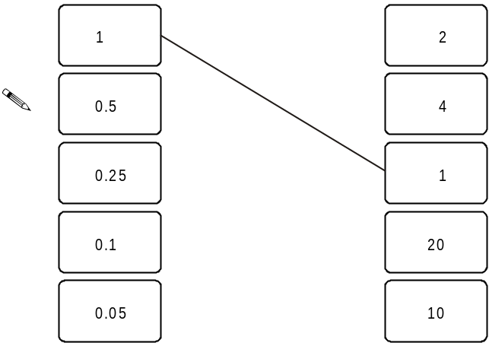
2 marks

2. Area or Rectangle

A rectangle measures twelve centimetres by four centimetres.
What is its area?
 ...............................
1 marks
3. 28 times table

(a) Show that 9 × 28 is 252
1 mark
(b) What is 27 × 28?
You can use part (a) to help you.
...............................
1 marks
4. Three angles
Three shapes ﬁt together at point B.
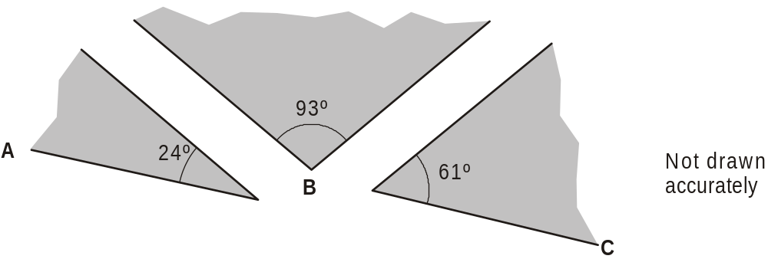
Will ABC make a straight line?
 Yes No
Explain your answer.
________________________________________________________________
_____________________________________________________________________
1 mark
5. Percentages
(a) Work out 5% of 360
.......................
1 mark
(b) Work out 15% of 360
You can use part (a) to help you.
....................... 1 mark

6. Temperature
What temperature is ten degrees lower than seven degrees Celsius?
.......................
1 mark
7. CD player
(a) Work out the missing values.
10% of 84 = ..................
5% of 84 = ..................
2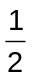% of 84 = ..................

2 marks
(b) The cost of a CD player is £84 plus 17% tax.
What is the total cost of the CD player?
You can use part (a) to help you.
£

2 marks
8. Decimals
Work out the following.
1.2 × 6
1 mark
1.2 ÷ 6

1 mark
9. I think of a number

I think of a number, subtract ten and double the result.
The answer is forty-four.
What is my number?
.............................
1 mark
10. Long multiplication
Work out
374 × 23
............................
1 mark
11. Fractions
What fraction of two pounds is twenty pence?
............................
1 marks
12. Properties of shapes

Imagine a triangular prism.
How many faces does it have?
............................
1mark
13. Measures
How many millimetres are there in fifteen centimetres?

............................
1 mark

14. Goldbach
A famous mathematician claimed that:
Every even number greater than 4 can be
written as the sum of a pair of prime numbers.
For example: 8 can be written as the sum of 3 and 5, and
3 and 5 are both prime numbers.

(a) Write a pair of prime numbers that sum to 16
............. and .............
1 mark
Now write a different pair of prime numbers that sum to 16
............. and .............
1 mark
(b) Now choose an even number that is greater than 16, then write a pair of prime numbers that sum to your even number.
Complete the sentence below.
The even number ............. can be written as
the sum of the prime numbers ............. and .............
1 mark

15. 3 times table
(a) Write the correct numbers in the gaps below.
1 × 3 = 3
2 × 3 = 7
3 × 3 = 10
4 × 3 = ...............
5 × 3 = ...............
6 × 3 = 21
1 marks
Use the table to help you work out this calculation.
60 × 3 = ...................
1 mark

(b) Is the answer to 11 × 3 a whole number?
Yes No
Explain your answer.
________________________________________________________________________________________________
1 mark

16. Fir trees
The graph shows the average heights of ﬁr trees of different ages.
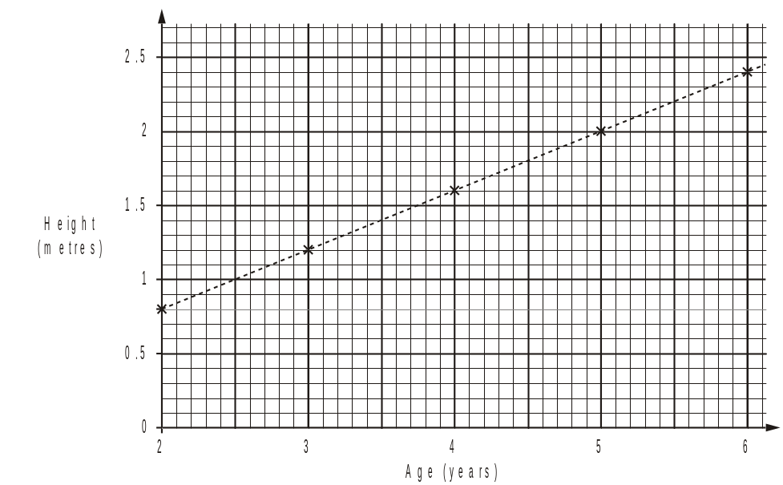
The table shows the cost of ﬁr trees of different heights.
 | 120 cm to 159 cm | 160 cm to 199 cm | 200 cm to 239 cm
Cost | £ 20.00 | £ 25.00 | £ 30.00
(a) One of these ﬁr trees is 5 years old.
How much is it likely to cost?
£ ......................
1 mark
(b) One of these ﬁr trees costs £ 25.00
How old is the tree likely to be?
Between ...................... and ...................... years old
1 mark

